Work Hour Calculator — Repository Analysis
Date: 2026-05-16

Overview
This repository implements a Work Hour Calculator that uses a laptop camera to detect whether an employee is "working" or "not_working". It combines MobileNet-SSD for person detection, MediaPipe for pose/hand/face landmarks, and a TensorFlow model for action classification.

Tech Stack
- Python
- OpenCV (cv2)
- MediaPipe
- TensorFlow / Keras
- CSV logging

Key Files
- Work_hour_Calc.py — main script that captures webcam feed, detects persons, extracts landmarks, predicts actions, and logs durations to CSV.
- Training.ipynb — notebook used for model training and experiments.
- requirements.txt — minimal list of Python dependencies.
- misc/ — contains thumbnail and demo video (not all large model files are stored in the repo).

How It Works
1. Capture webcam frames and run MobileNet-SSD to find person bounding boxes.
2. Crop each detected person and run MediaPipe Holistic to extract face, pose, and hand landmarks.
3. Convert landmarks into a fixed-size feature vector (padding as needed) and create a temporal sequence (30 frames).
4. Feed the padded sequence to the provided TensorFlow model (`actions_w_w_3.h5`) to get probabilities for `working` vs `not_working`.
5. Track the current action and log durations to `activity_log.csv` whenever the action changes or on exit.

Strengths
- Uses lightweight person detector (MobileNet-SSD) and MediaPipe for robust landmark extraction.
- Simple CSV logging for easy downstream analysis.
- Training notebook included for reproducing the model.

Limitations & Notes
- Requires pre-trained model files: `deploy.prototxt`, `mobilenet_iter_73000.caffemodel`, and `actions_w_w_3.h5`.
- Heavy runtime dependencies (TensorFlow, MediaPipe, OpenCV) and possibly GPU for reasonable performance.
- Privacy: continuous camera monitoring requires consent and secure handling of logs.
- Accuracy depends on the quality and representativeness of training data; may misclassify brief activity or occlusions.

How to Run
1. Clone the repository:
git clone https://github.com/0shazil0/Work_Hour_Calculator.git
2. Install dependencies from `requirements.txt` (or install: numpy, mediapipe, opencv-python, tensorflow).
3. Place model files (`deploy.prototxt`, `mobilenet_iter_73000.caffemodel`, `actions_w_w_3.h5`) into the repository root.
4. Run the main script: `python Work_hour_Calc.py`

Recommendations / Next Steps
- Add a requirements pin file (versions) and an installation guide for platform-specific steps.
- Add error handling if model files are missing, and clearer user messages for camera selection.
- Consider packaging the project or adding a simple GUI to control recording and export summaries.

Included Image
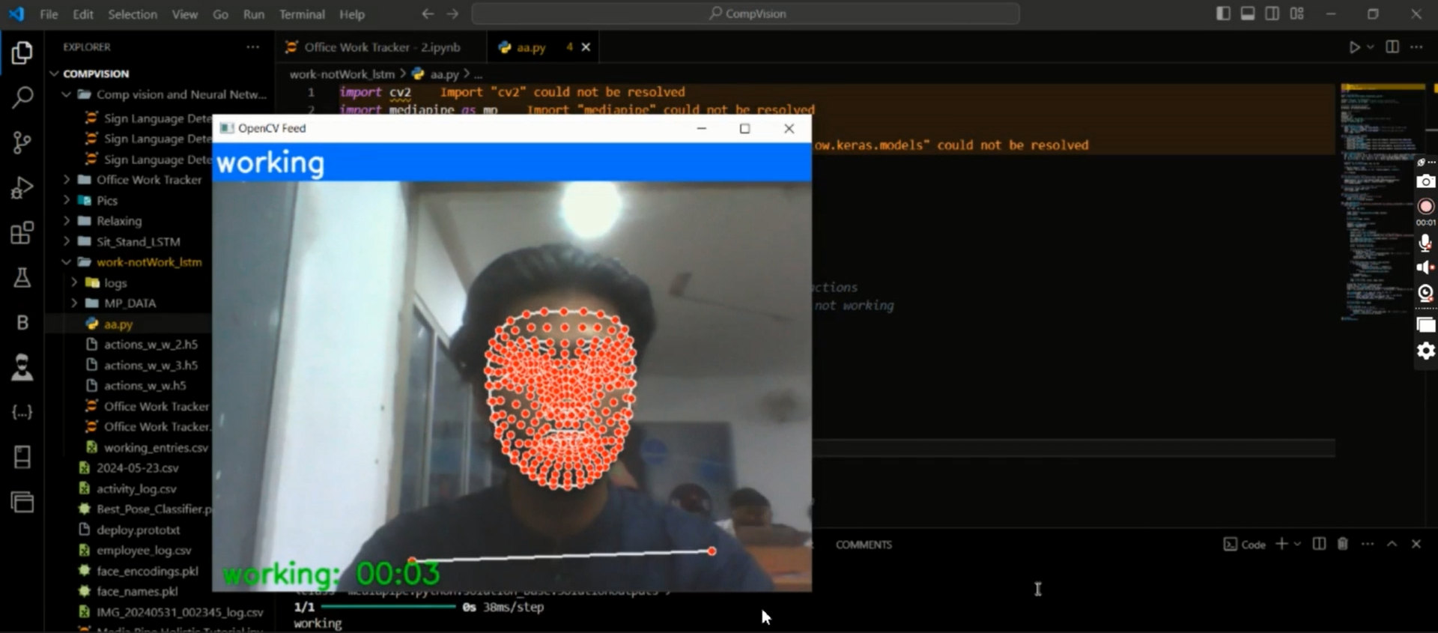
#file:workhourcalculator.png

Short Summary for Portfolio
A practical prototype that demonstrates using computer vision and pose estimation to estimate active work time from a laptop camera. Good starting point for research or a proof-of-concept; requires additional work for production readiness.

